Katelyn Morrey
Geography B2
Homework #19

Country #1 Germany
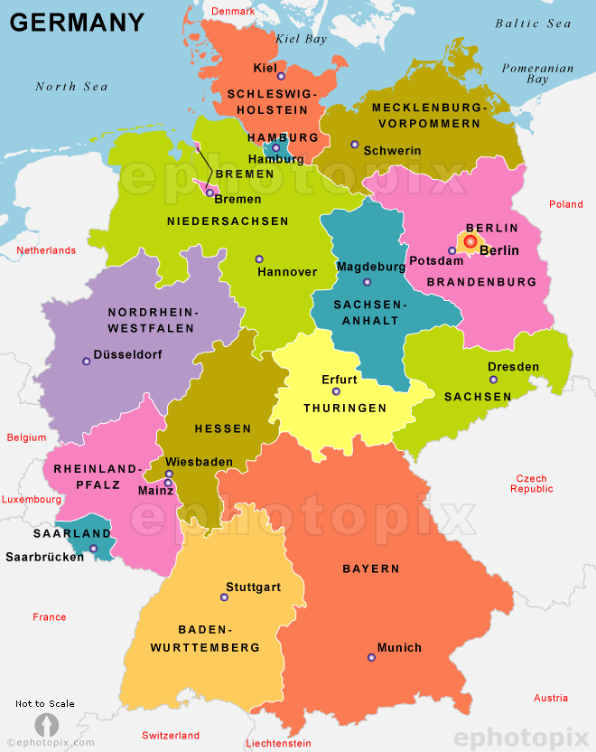
Political Map:

Physical Map: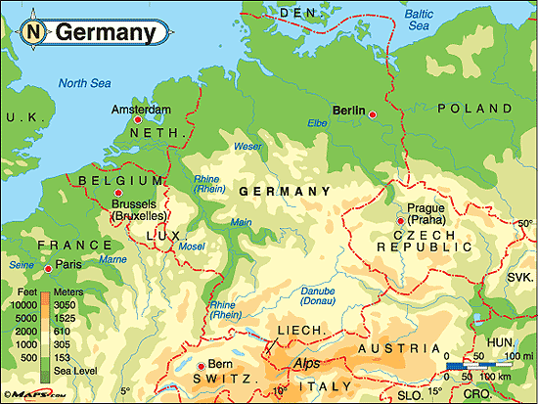
Physical Features:
- Bavarian Alps
- Lower Rhenish Bight
- Zugspitze (Northern Alps)
- Mosel
Pictures of Physical Features.
1. Mosel 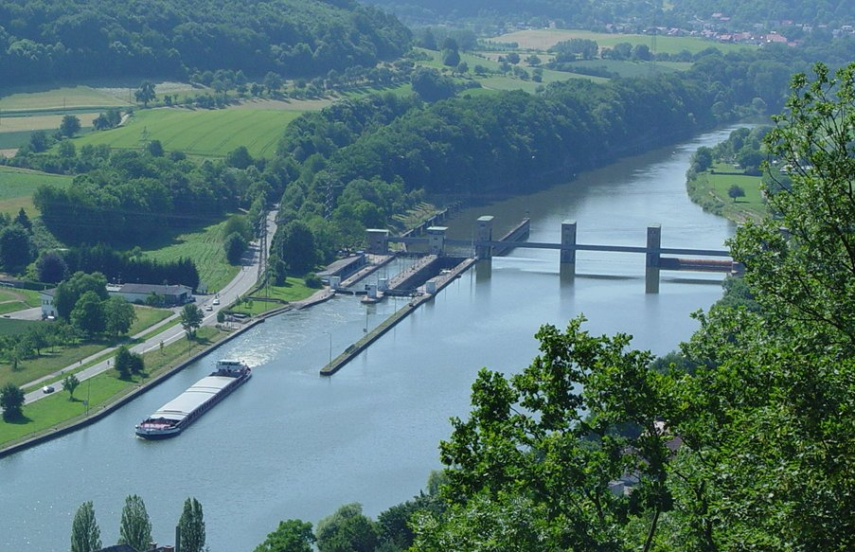
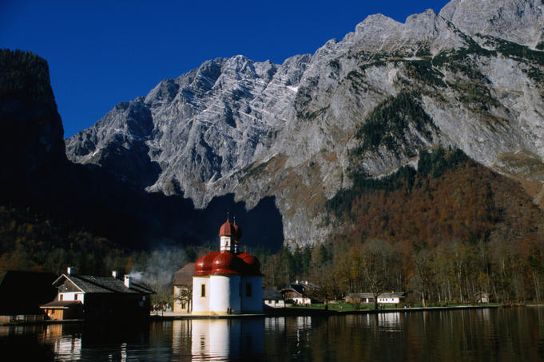
2. Bavarian Alps
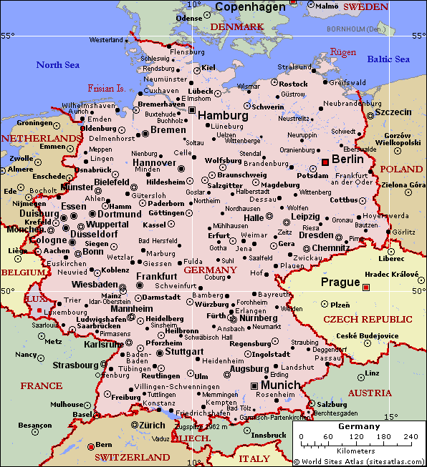
Map:

Country #2 China
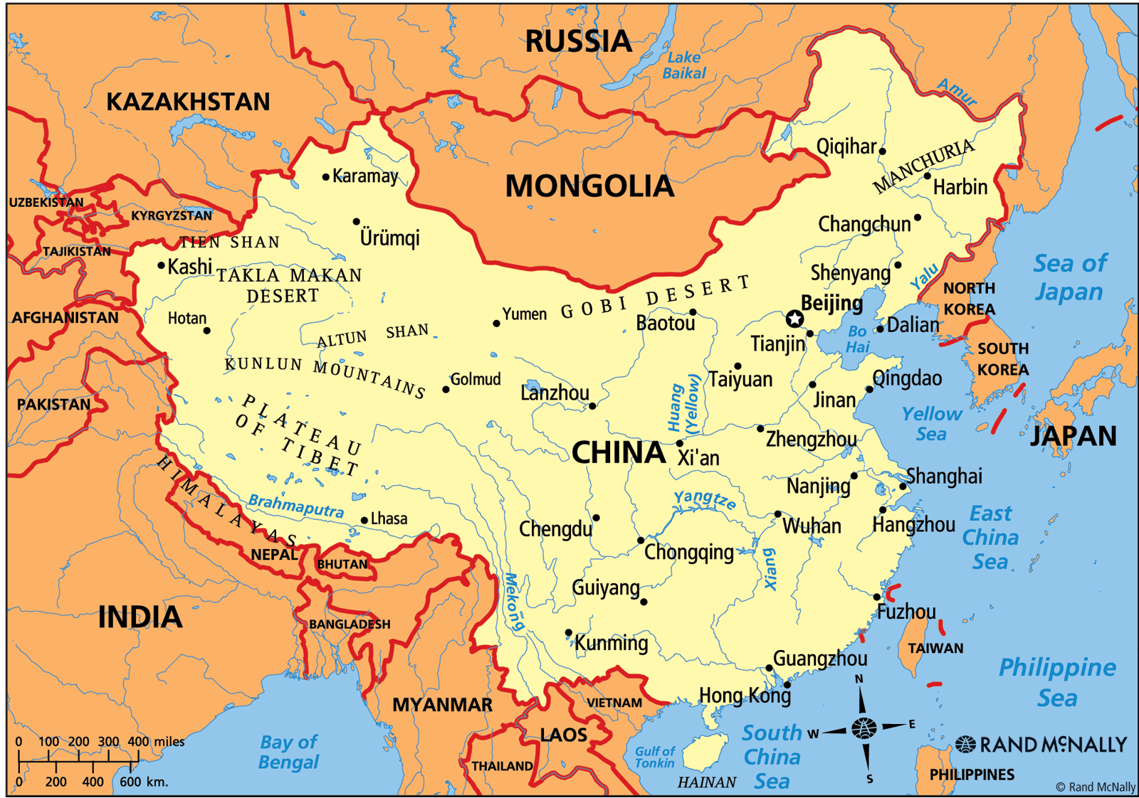
Political Map:

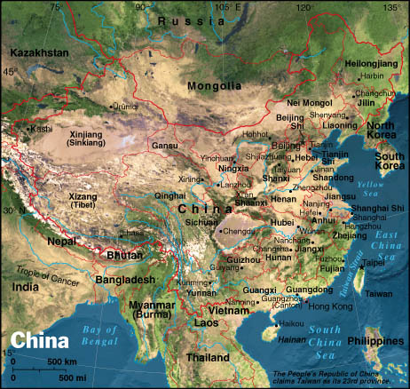
Physical Map:

Physical Features:
- Qinghai-Tibet Plateau
- Hengduan mountain chain
- Taihang
- Bajiaozhai (Eight Horns Mountain)
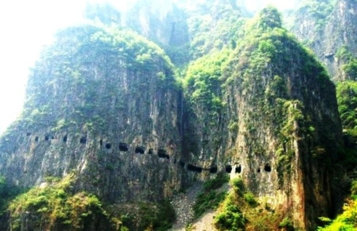
Pictures of Physical Features.
- Taihang

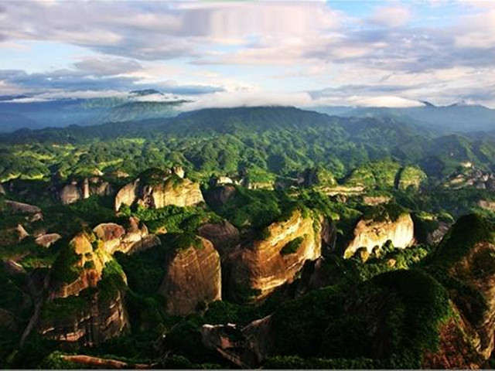
- Bajiaozhai (Eight Horns Mountain)

Map:
